Problem: What are we building and why is it useful?
We are building a YOLO model that takes a satellite image and automatically detects as well as counts the number of buildings in it.
This is useful in the context of our project Pixels-to-Parcels because we are trying to do something similar. From satellite imagery and building detection, we can estimate the number of buildings and houses in an area. This analysis can help in establishing dark stores in the right locations so that we can target a larger market and also maintain fast delivery, which helps in building customer trust.

Data: Where it came from, how many images, what the labels look like?
We used the SpaceNet dataset via Kaggle. It had satellite images of buildings in Paris. There were 1150 train images and 381 test images. No validation folder was provided. So, we created our own validation split from the training data.
The labels were provided in GeoJSON format and contained polygon coordinates for building footprints in each image. These labels were later converted into YOLO bounding box format for training the model.
Problem: What are we building and why is it useful?
We are building a YOLO model that takes a satellite image and automatically detects as well as counts the number of buildings in it.
This is useful in the context of our project Pixels-to-Parcels because we are trying to do something similar. From satellite imagery and building detection, we can estimate the number of buildings and houses in an area. This analysis can help in establishing dark stores in the right locations so that we can target a larger market and also maintain fast delivery, which helps in building customer trust.

Data: Where it came from, how many images, what the labels look like?
We used the SpaceNet dataset via Kaggle. It had satellite images of buildings in Paris. There were 759 train images and 95 test images. No validation folder was provided. So, we created our own validation split from the training data.
The labels were provided in GeoJSON format and contained polygon coordinates for building footprints in each image. These labels were later converted into YOLO bounding box format for training the model.
Here's a rewritten version with different wording while keeping the same information:

Model: What is YOLOv8, which version was selected, and how many parameters does it have?
YOLOv8 (You Only Look Once Version 8), developed by Ultralytics, is a state-of-the-art deep learning model designed for computer vision tasks. It is widely used for object detection, image segmentation, and classification because of its balance between speed and accuracy. Its efficiency makes it a popular choice for real-world applications that require fast and reliable predictions.
For this project, we selected YOLOv8s (Small) as the detection model. This variant provides a good trade-off between computational efficiency and performance. The model contains approximately 11.1 million trainable parameters (11,135,987).

Training Setup: Epochs, Batch Size, Hardware, and Training Duration
The model was trained for 10 epochs using a batch size of 16. Training was carried out on an NVIDIA Tesla T4 GPU with 14,913 MiB of available memory.
The complete training process took approximately 0.05 hours, which is about 3minutes and 57 seconds (roughly 4 minutes). The use of GPU acceleration significantly reduced the training time and allowed the model to converge efficiently.
.

Metric | Value | Description
mAP@50 | 0.7816 | Average detection accuracy at a 50% Intersection over Union (IoU) threshold.
Precision | 0.7866 | Percentage of predicted building detections that were actually correct.
Recall | 0.7063 | Percentage of real buildings that were successfully detected by the model.
F1 Score | 0.7443 | Harmonic mean of Precision and Recall, representing the overall detection performance.
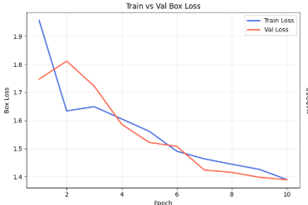
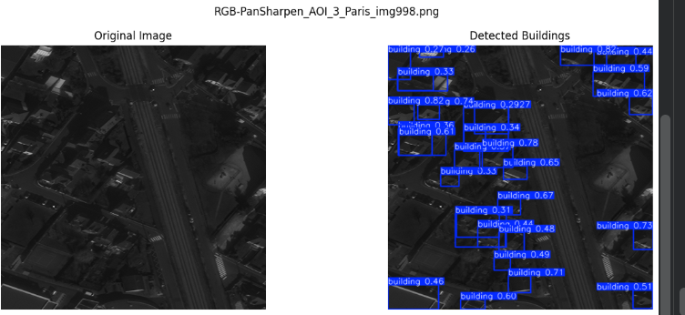
Here's a rephrased version that conveys the same points in a more original academic style:

Model Performance Analysis
Strengths of the Model
- Despite being trained for only 10 epochs, the model achieved an mAP@50 of 0.7816 on the test dataset, demonstrating a satisfactory ability to identify buildings in satellite imagery.
- The precision score of 0.7866 indicates that the majority of the predicted building detections were correct, resulting in relatively few false-positive predictions.
- The model obtained a Mean Absolute Error (MAE) of 2.70 for building counting, suggesting that it can reasonably estimate the number of buildings present in an image.
Limitations Observed
- The dataset contains a large number of images without any buildings (352 out of 759 training images), creating a class imbalance that may affect the model’s ability to generalize effectively across different building densities.
- The recall value of 0.7063 is lower than the precision score, indicating that some buildings present in the images were not detected by the model.
- Differences between actual and predicted building counts in several sample images reveal that the model still struggles to capture every building accurately.
Potential Improvements
- Extending the training duration could enhance performance. Since the model was trained for only 10 epochs, increasing the number of epochs (for example, to 50 or more) may allow it to learn more representative features and improve both recall and overall detection accuracy.
- The training metrics suggest that the model had not yet fully converged, indicating further training could yield better results.

